**Topics: Normal distribution, Functions of Random Variables**

1. The time required for servicing transmissions is normally distributed with *μ* = 45 minutes and *σ* = 8 minutes. The service manager plans to have work begin on the transmission of a customer’s car 10 minutes after the car is dropped off and the customer is told that the car will be ready within 1 hour from drop-off. What is the probability that the service manager cannot meet his commitment?
2. 0.3875
3. 0.2676
4. 0.5
5. 0.6987

Ans : we have a normal distribution μ=45 and σ=8,if service manager start his work 10 minutes (x<50),and we have to find probability that he cannot meet his commitment P(x>50).

We known that probability is between 0 to 1

P(x>50) =1-(x<50)

Z=(x-μ)/σ

Z= 50-45/8=0.625

Z=0.625=73.4%

To find P(x>50) = 100 – 73.4% =26.6% 0r 0.267

1. The current age (in years) of 400 clerical employees at an insurance claims processing center is normally distributed with mean *μ* = 38 and Standard deviation *σ* =6. For each statement below, please specify True/False. If false, briefly explain why.
2. More employees at the processing center are older than 44 than between 38 and 44.

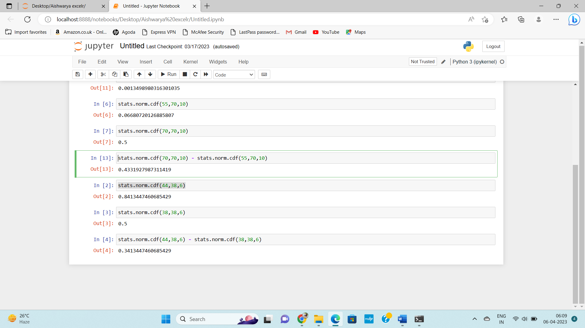

From the code we can infer that age is greater than 44 is 0.8413

And age is between 38 is 0.5,and the age between 44 – 38 is 0.3413 or 34%

So ,we can say that the given statement is true.

1. A training program for employees under the age of 30 at the center would be expected to attract about 36 employees.

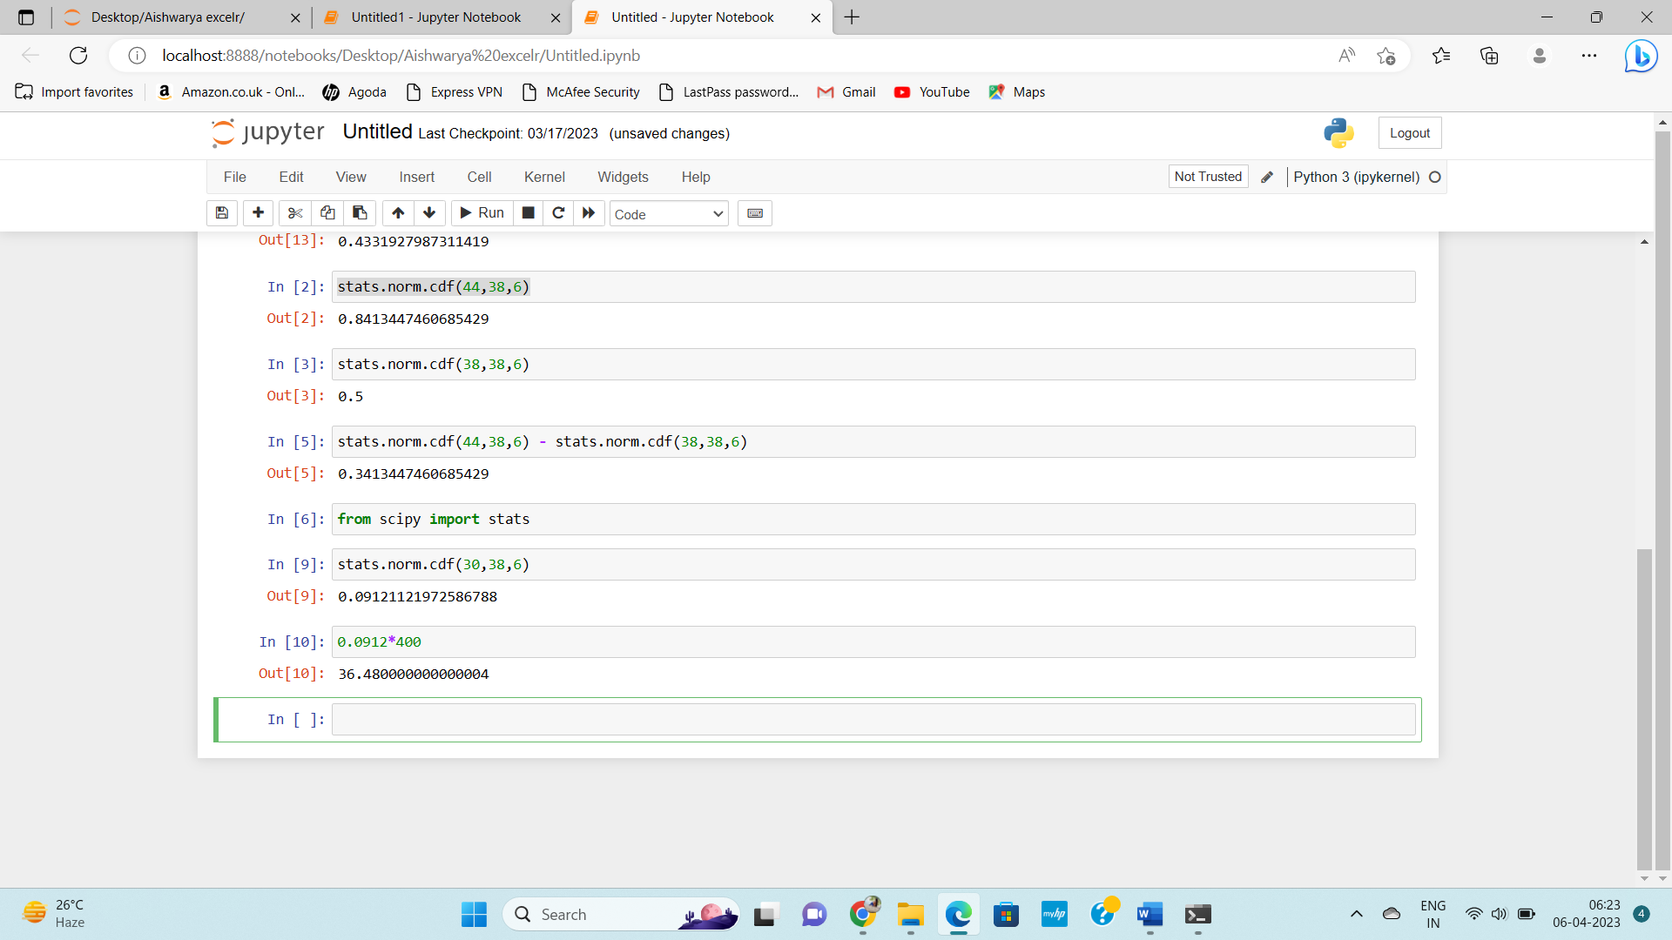

From the code we can infer that probability of age under the 30 is 0.0912 0r 9.12%

If the total no. of employee are 400 so 400*0.0912 = 36.48 ,so it is attracting 36 employee.

1. If *X1* ~ *N*(μ, σ2) and *X*2 ~ *N*(μ, σ2) are *id* normal random variables, then what is the difference between 2 *X*1 and *X*1 + *X*2? Discuss both their distributions and parameters.

**Normal distribution** is defined by two parameters, the **mean**, , and the **variance**,  and written as X~N(μ,σ^2)

Given X1~N(μ,σ^2) and X2~N(μ,σ^2)  are two independent identically distributed random variables. The

Sum of normal random variable is given by

X + Y~N(μ1 + μ2 ,σ1^2 + σ2^2)

To find 2X1

2X =N(2μ ,2^2 σ^2) = 2X=N(2μ,4 σ^2)

X1 + X2 = N(μ +μ,σ^2 +σ^2) =N(2μ,2σ^2)

2X1-(X1-+X2) = N(2μ-2μ , 2 σ2 +  4σ2)= N=(0, 6σ2 )

the mean of 2X! and X1 and X2 is same

1. Let X ~ N(100, 202). Find two values, *a* and *b*, symmetric about the mean, such that the probability of the random variable taking a value between them is 0.99.
2. 90.5, 105.9
3. 80.2, 119.8
4. 22, 78
5. 48.5, 151.5
6. 90.1, 109.9

Ans : we known the empirical rule ,for 0.99 it will be μ+/-3σ

So , μ=100 and σ = 20

100+3*20=100+60=160

100-3*20=100-60=40

Ans is between 48.5 and 151.5

1. Consider a company that has two different divisions. The annual profits from the two divisions are independent and have distributions Profit1 ~ N(5, 32) and Profit2 ~ N(7, 42) respectively. Both the profits are in $ Million. Answer the following questions about the total profit of the company in Rupees. Assume that $1 = Rs. 45

Ans: The company is divided into two division and the annual profits from the two division are independently distributed ,

So, for profit1-μ=5 , σ=3

For Profit 2 – μ=7 , σ=4

And company profit are in $, $1=Rs. 45

1. Specify a Rupee range (centered on the mean) such that it contains 95% probability for the annual profit of the company.

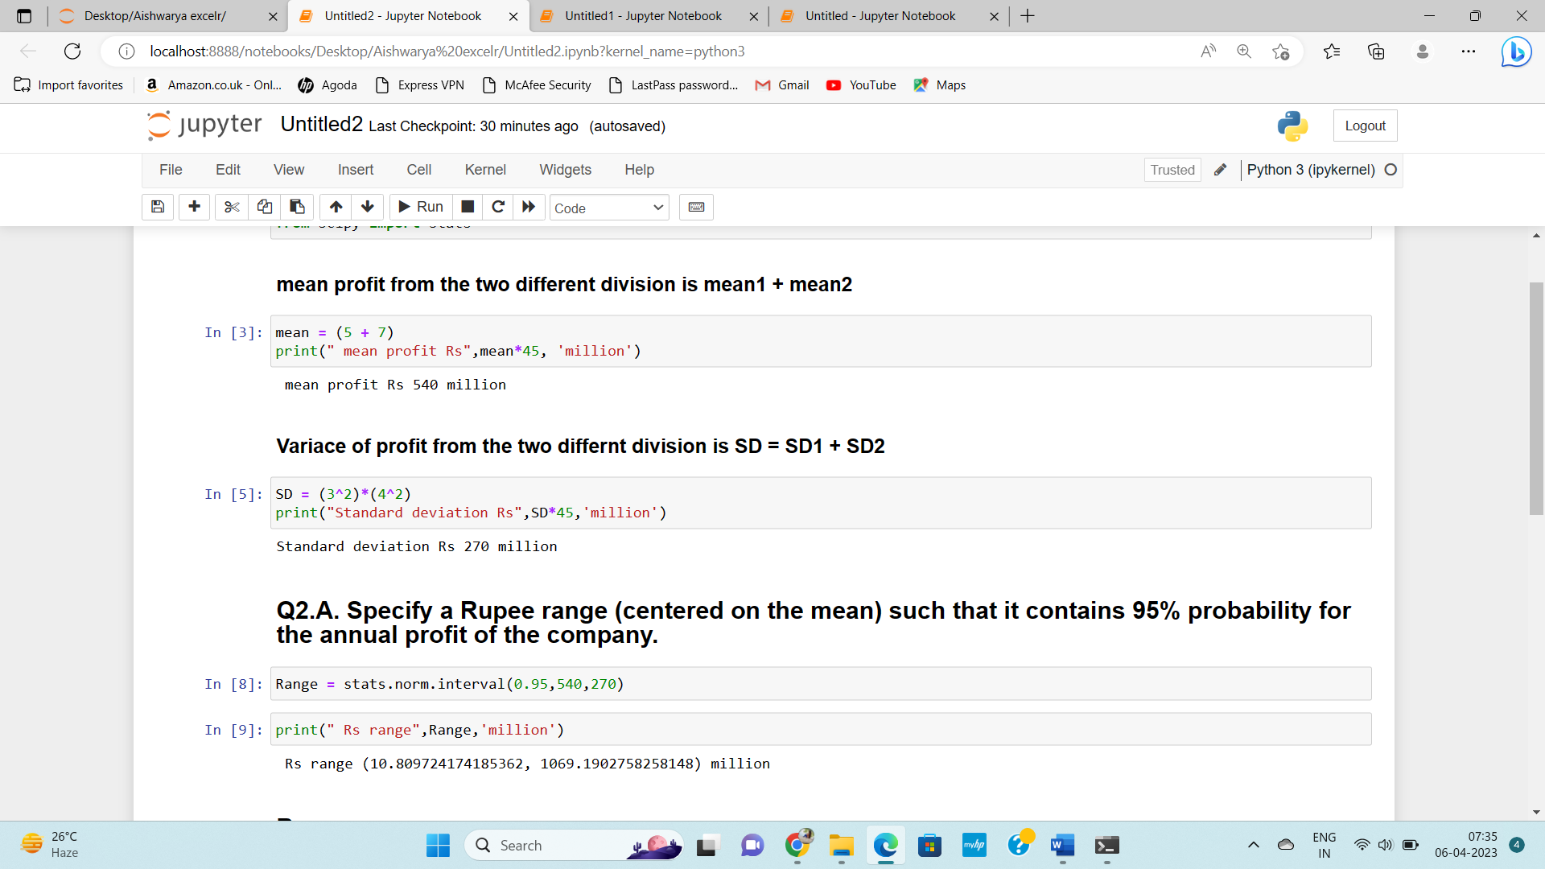

1. Specify the 5th percentile of profit (in Rupees) for the company

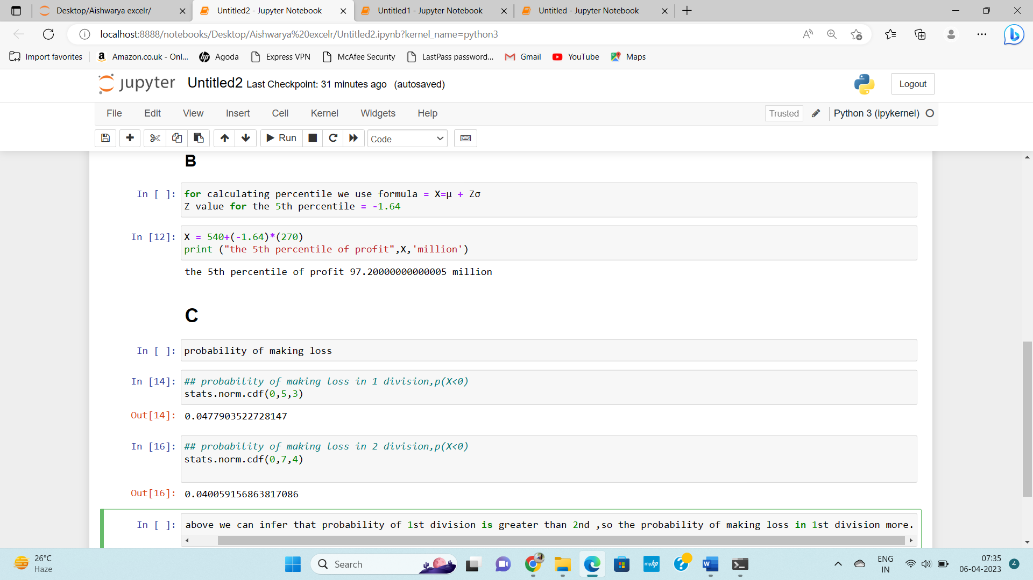

Which of the two divisions has a larger probability of making a loss in a given year?

